2021 Year 11 Mathematics Methods

**INVESTIGATION 1: Transformations**

**Calculator Assumed**

TAKE HOME SECTION

**NAME:** _________________________________________ **TEACHER:** ____________________________________________

**DUE DATE:** Wednesday 17 March 2021

**INSTRUCTIONS:**

Complete this take home section BEFORE the inclass validation on the morning of Wednesday 17 March.

Bring your ClassPad and this completed take home section with your working out for the validation.

You will have access to this take home section plus an additional two pages of notes in the validation.

**This page has been left blank intentionally.**

To find a linear equation using regression line (line of best fit).

* Find two or more clear points on the graph.
* (-1,4), (0,1) and (1.-2)
* Enter the co-ordinates into list 1 and list 2 in Statistics
* Calculate the Linear Regression line
* 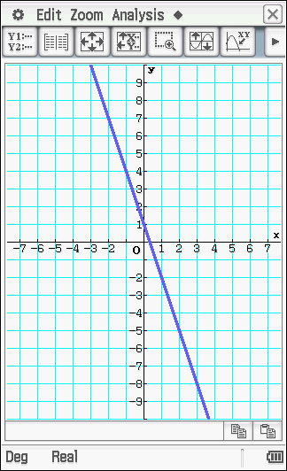 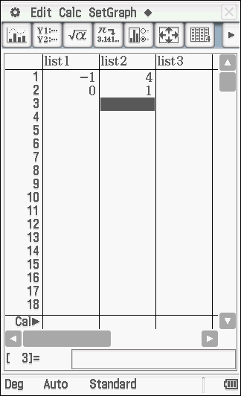 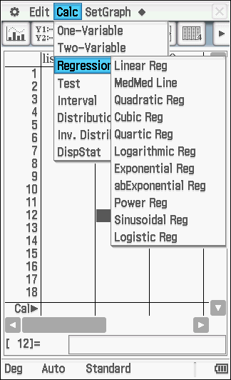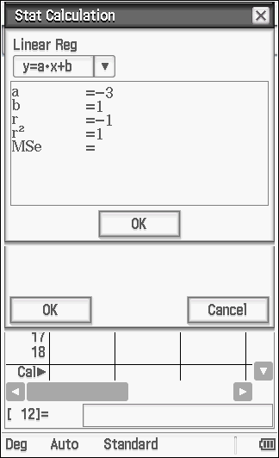

Therefore line of best fit is , notice , indicating a perfect fit.

Use the same methodology to find the quadric equation for the following graph. Note a quadratic will need at least three clear points.

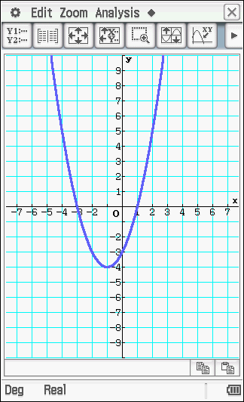

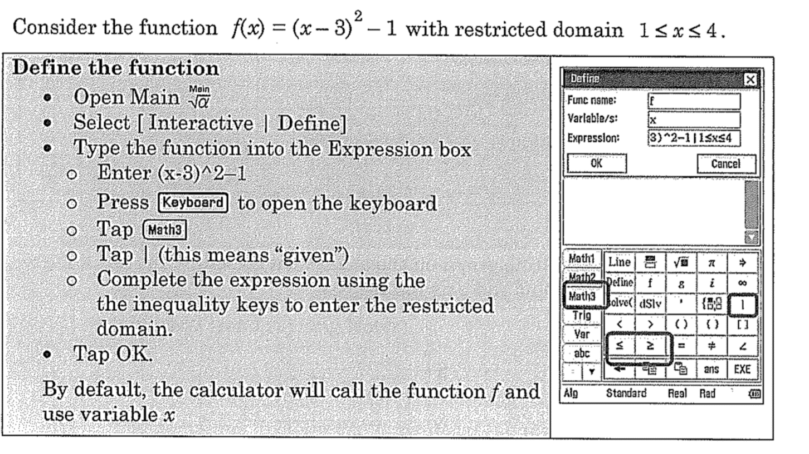

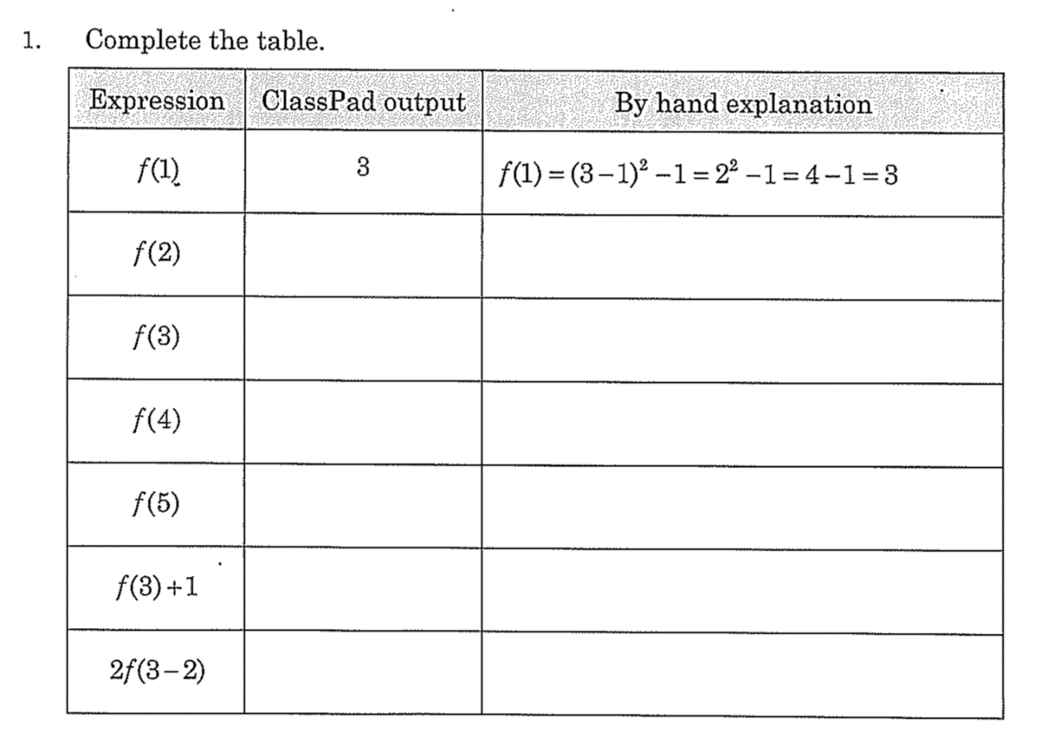

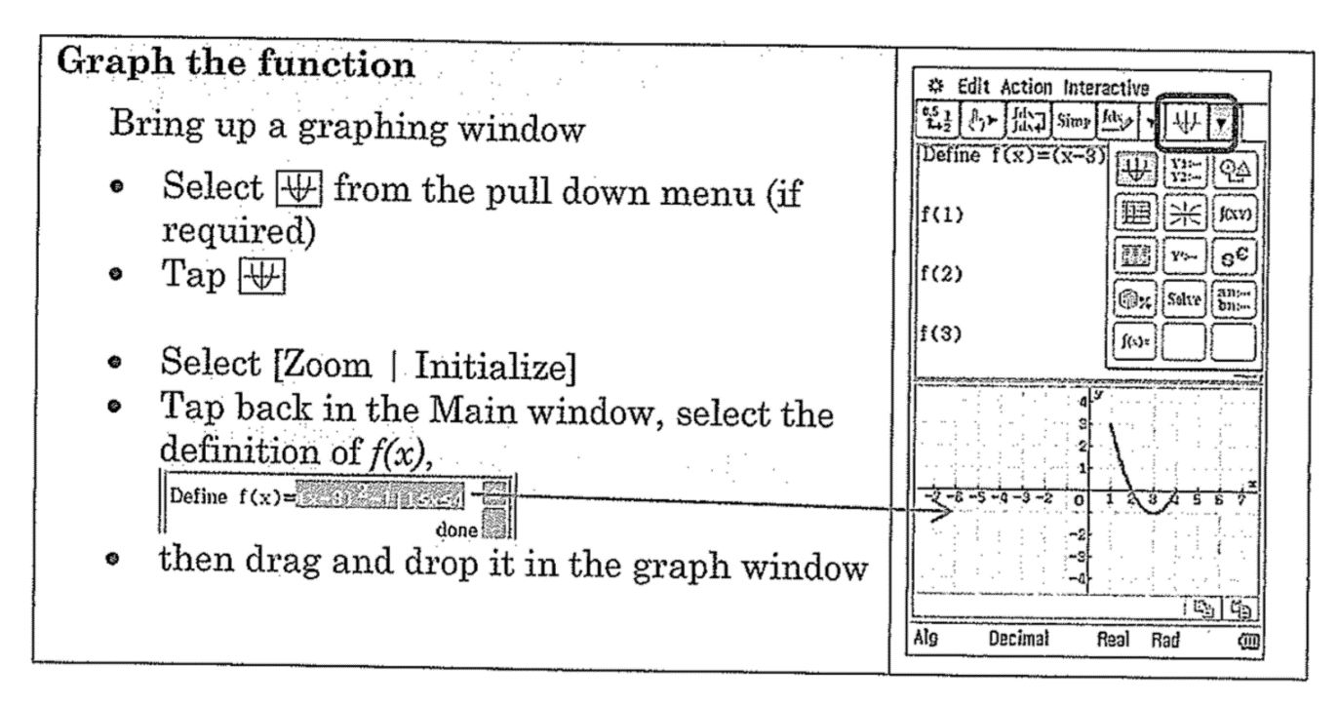

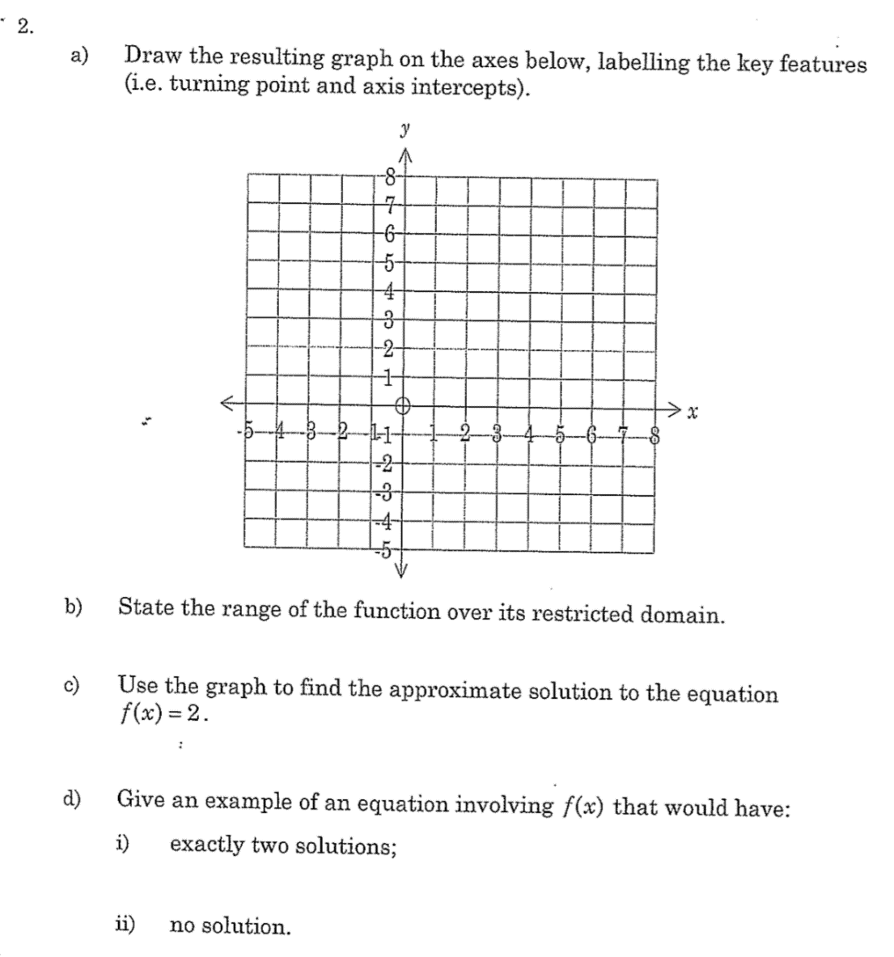

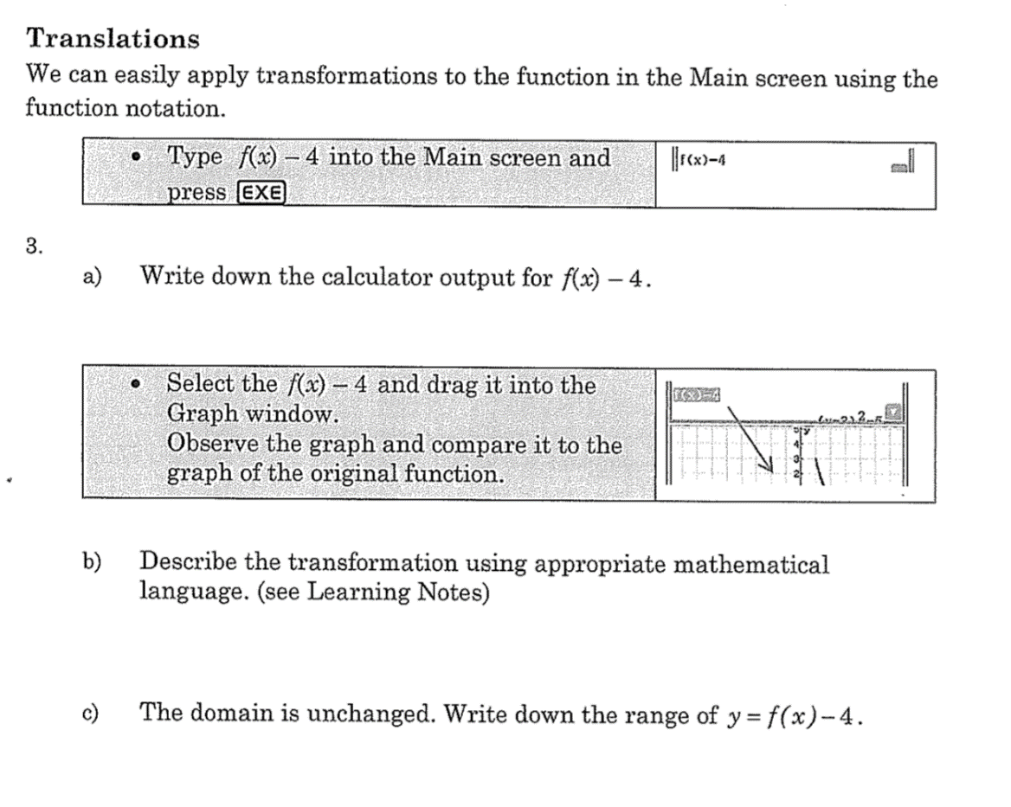

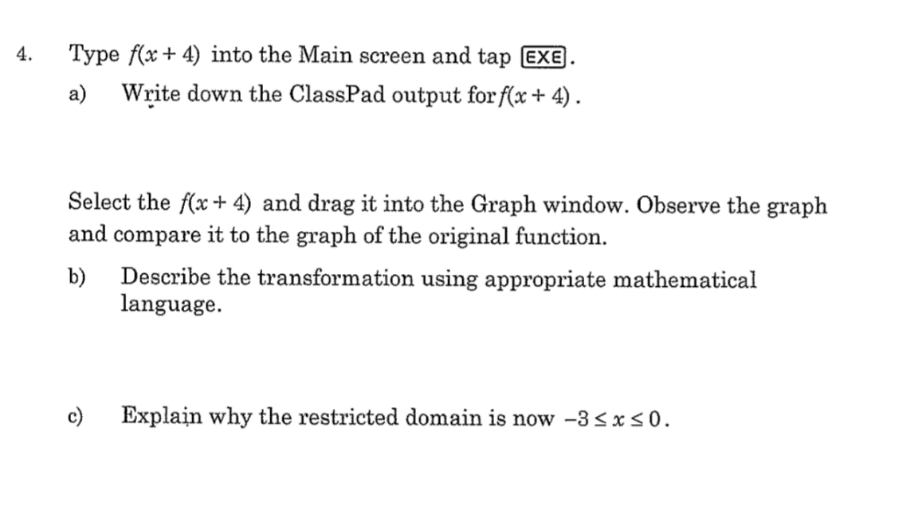

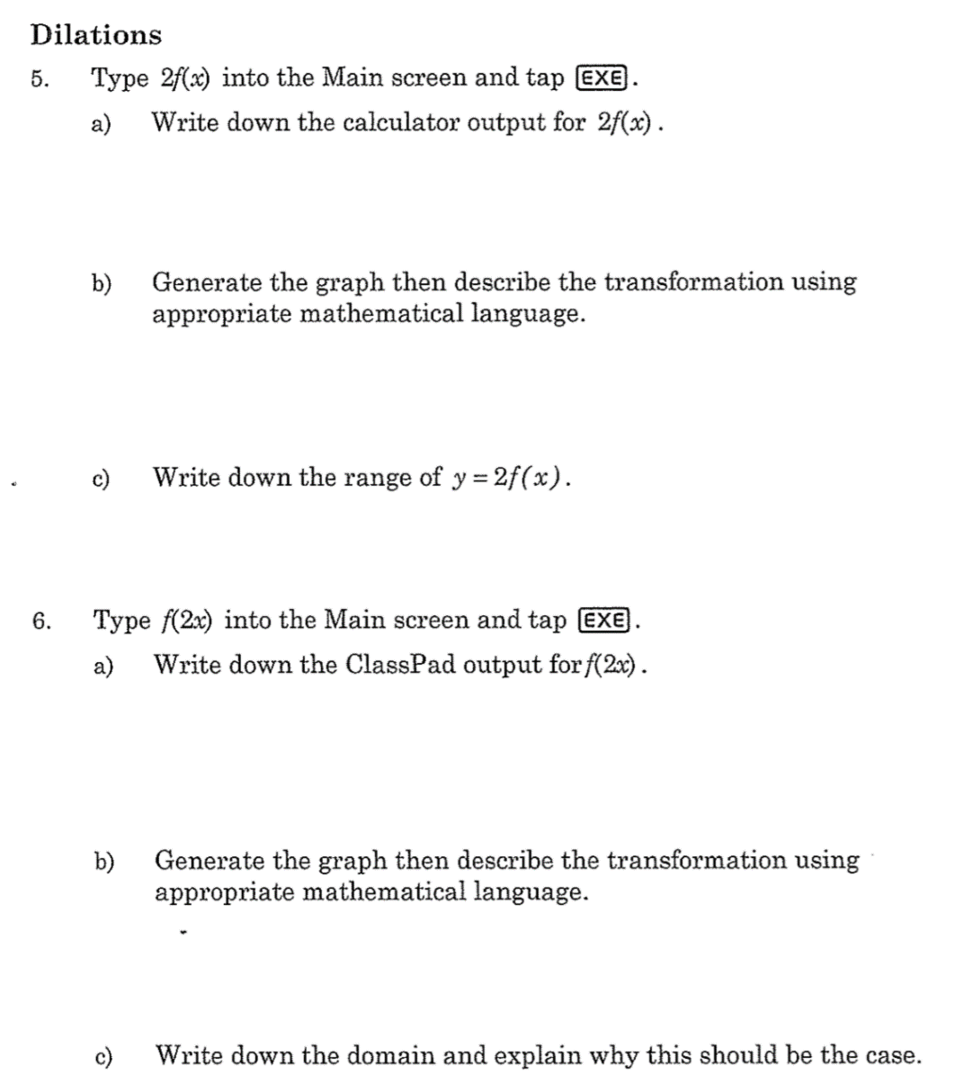

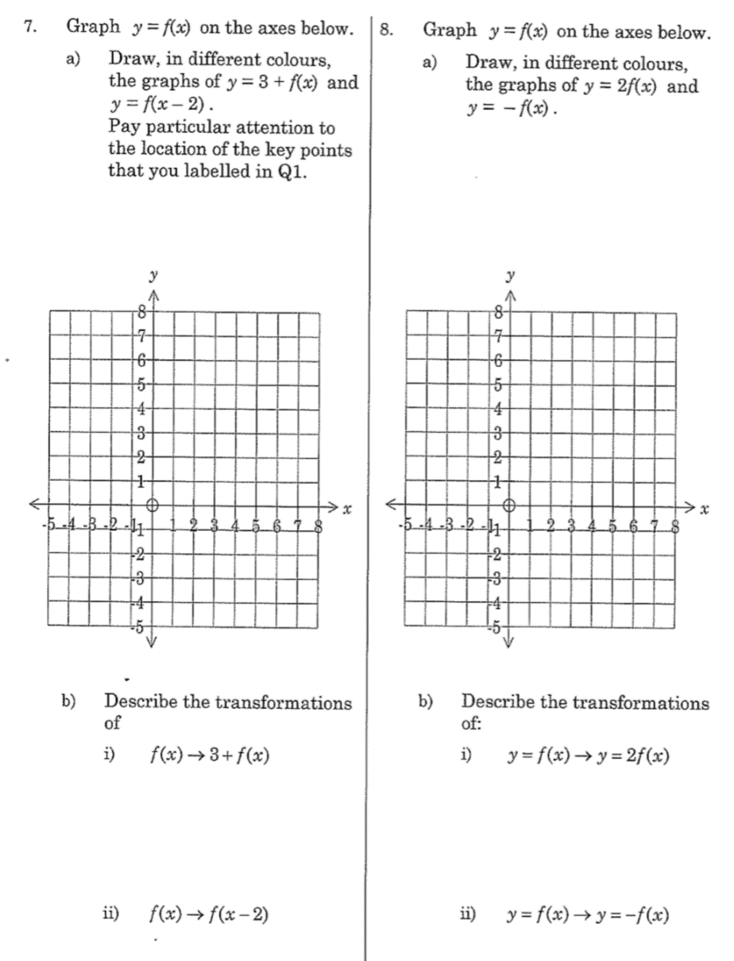

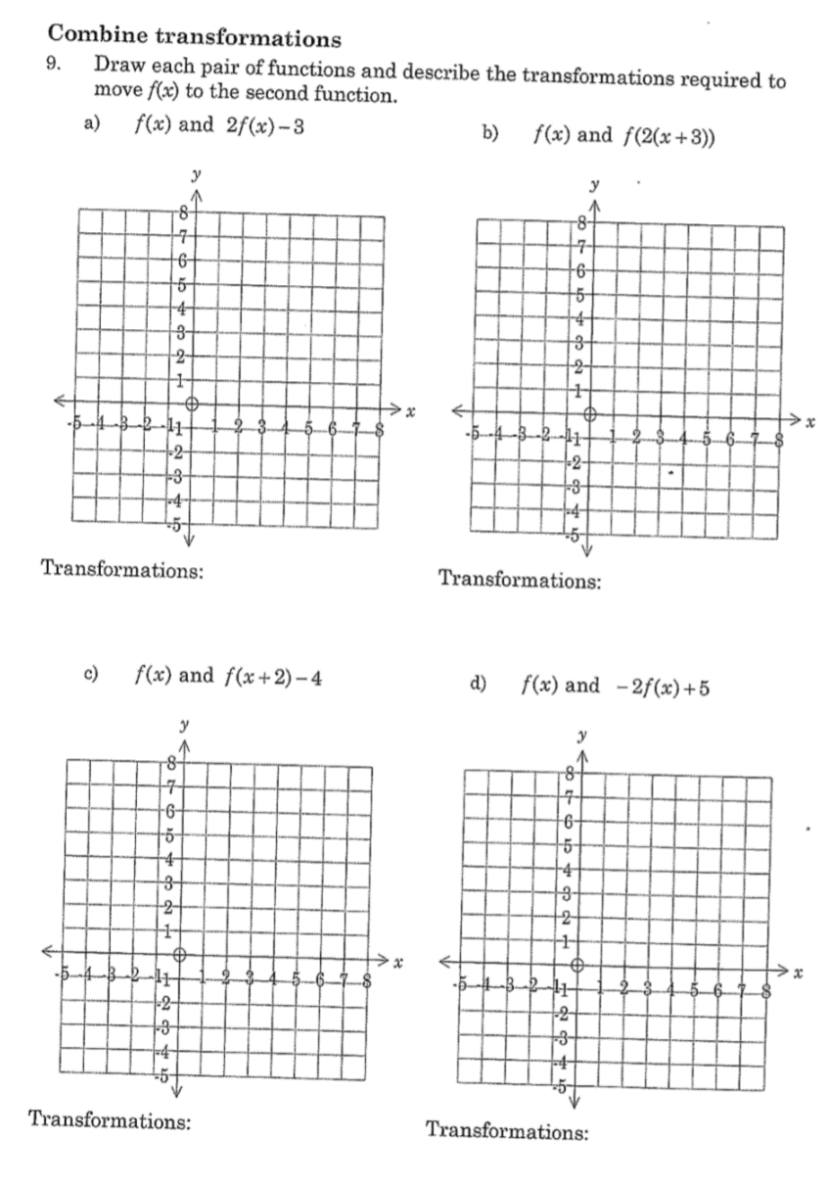

**Modelling with Transformations**

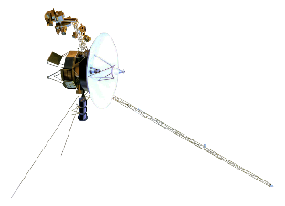10. Using the transformations of functions we are able to model real world objects. This is useful in modern engineering to simulate and test designs before starting expensive building processes.

In this exercise we will use the Voyage 1 spacecraft as an example. This space craft was launched by NASA in 1977 and in 2012 become the first human built object to pass the Heliopause and move into interstellar space. It is expected that Voyage 1 will continue to provide scientific data until 2025.

One of the defining features of Voyager 1 is the large parabolic reflector dish mounted on it. This dish is part of the communications system and supports the extreme long range communication.

Given the parabolic dish has a diameter of 3.66 meters and depth of 0.8 meters (use these values for this exercise).



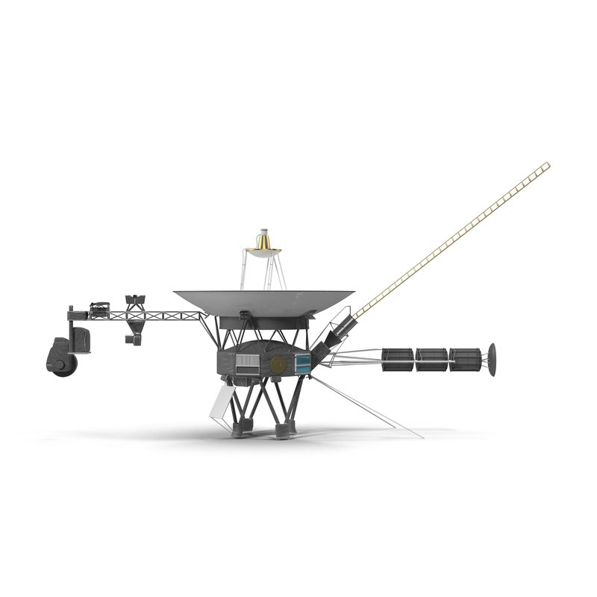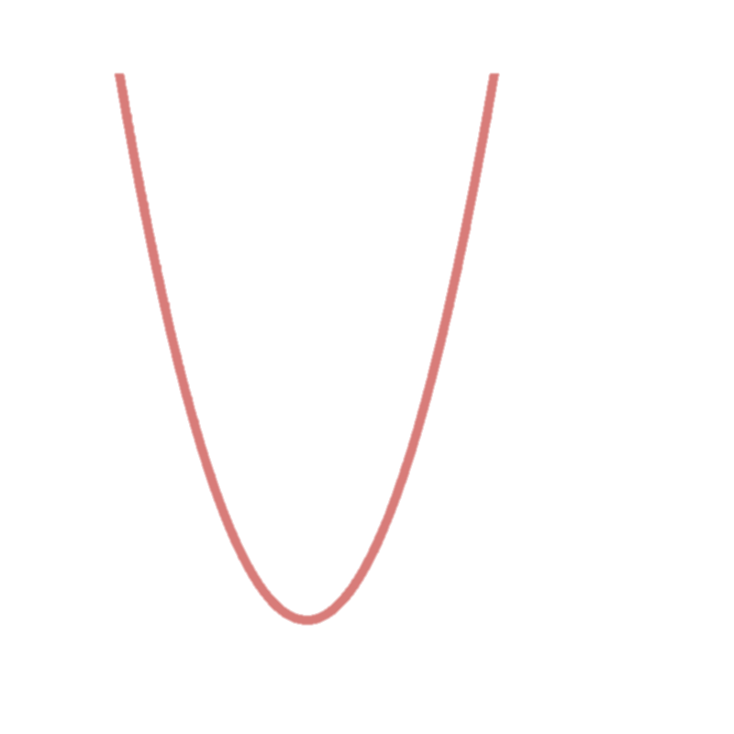

For the function that represents the Reflector Dish, as shown on the graph on the previous page.

1. State the coordinate of all intercepts.
2. State the coordinate of the vertex for the Reflector Dish Function

Use the turning point form :

1. Calculate **a** (to 4 decimal places)
2. Calculate **h** to (1 decimal place)
3. Calculate **k** to (nearest unit.)
4. If , State the transformations required to make f(x) transform into the Reflector Dish Function.
5. State the Reflector Dish function in terms of f(x)